- Introduction to OSPF Theory

Q1. Open Cisco Packet Tracer and create a simple network with three routers connected in a triangle topology using serial or Ethernet links?

Answer
- I created a triangle network topology in Cisco Packet Tracer using three 2811 routers (Router0, Router1, and Router2).
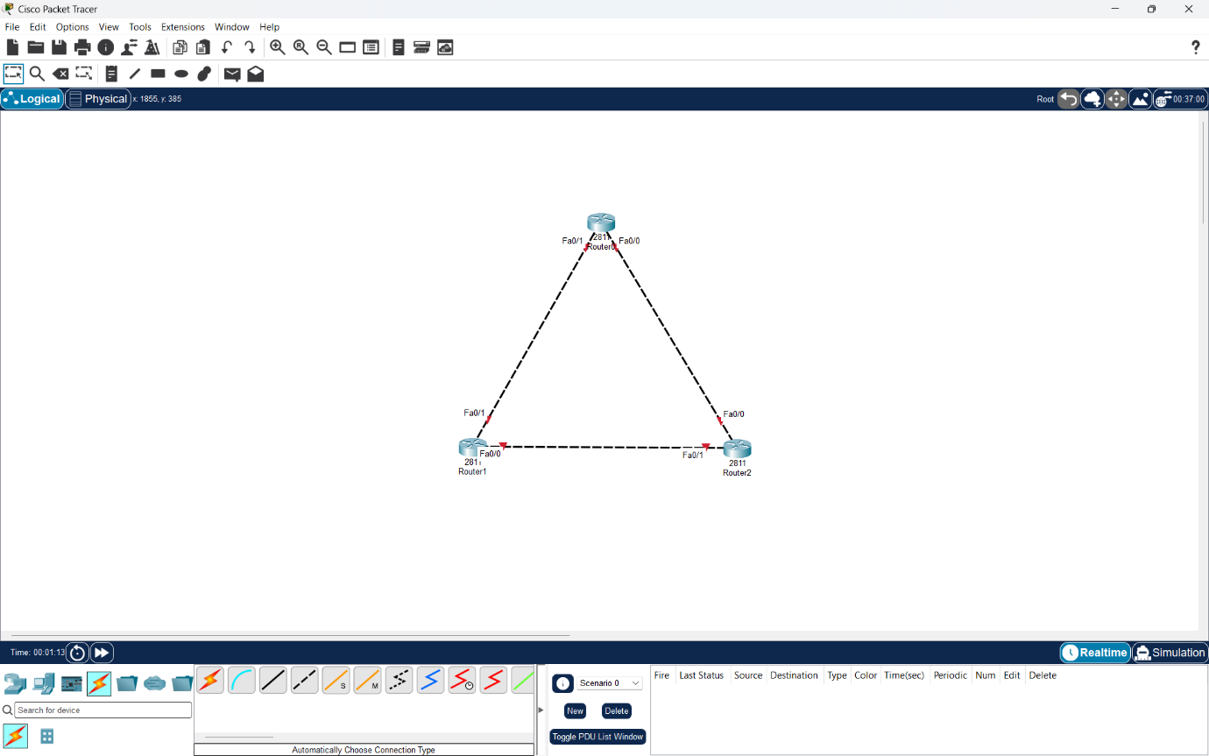
- I connected all three routers using Ethernet cables so that each router is directly connected to the other two routers.

Q2. Assign IP addresses to all router interfaces in your Packet Tracer network and verify connectivity using the ping command?

Answer
- I assigned IP addresses to all three routers using a /30 subnet mask (255.255.255.252).
- I configured three different networks: 195.168.1.0/30, 195.168.1.4/30 and 195.168.1.8/30.
- After configuring the router interfaces, I tested connectivity using the ping command.
- Result: Both ping tests were successful with an 80% success rate (4/5), confirming connectivity between directly connected routers.

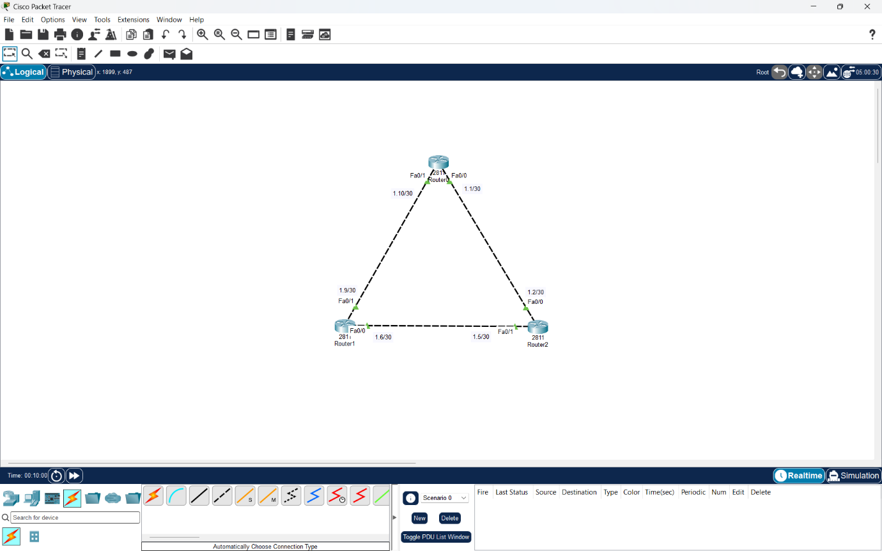

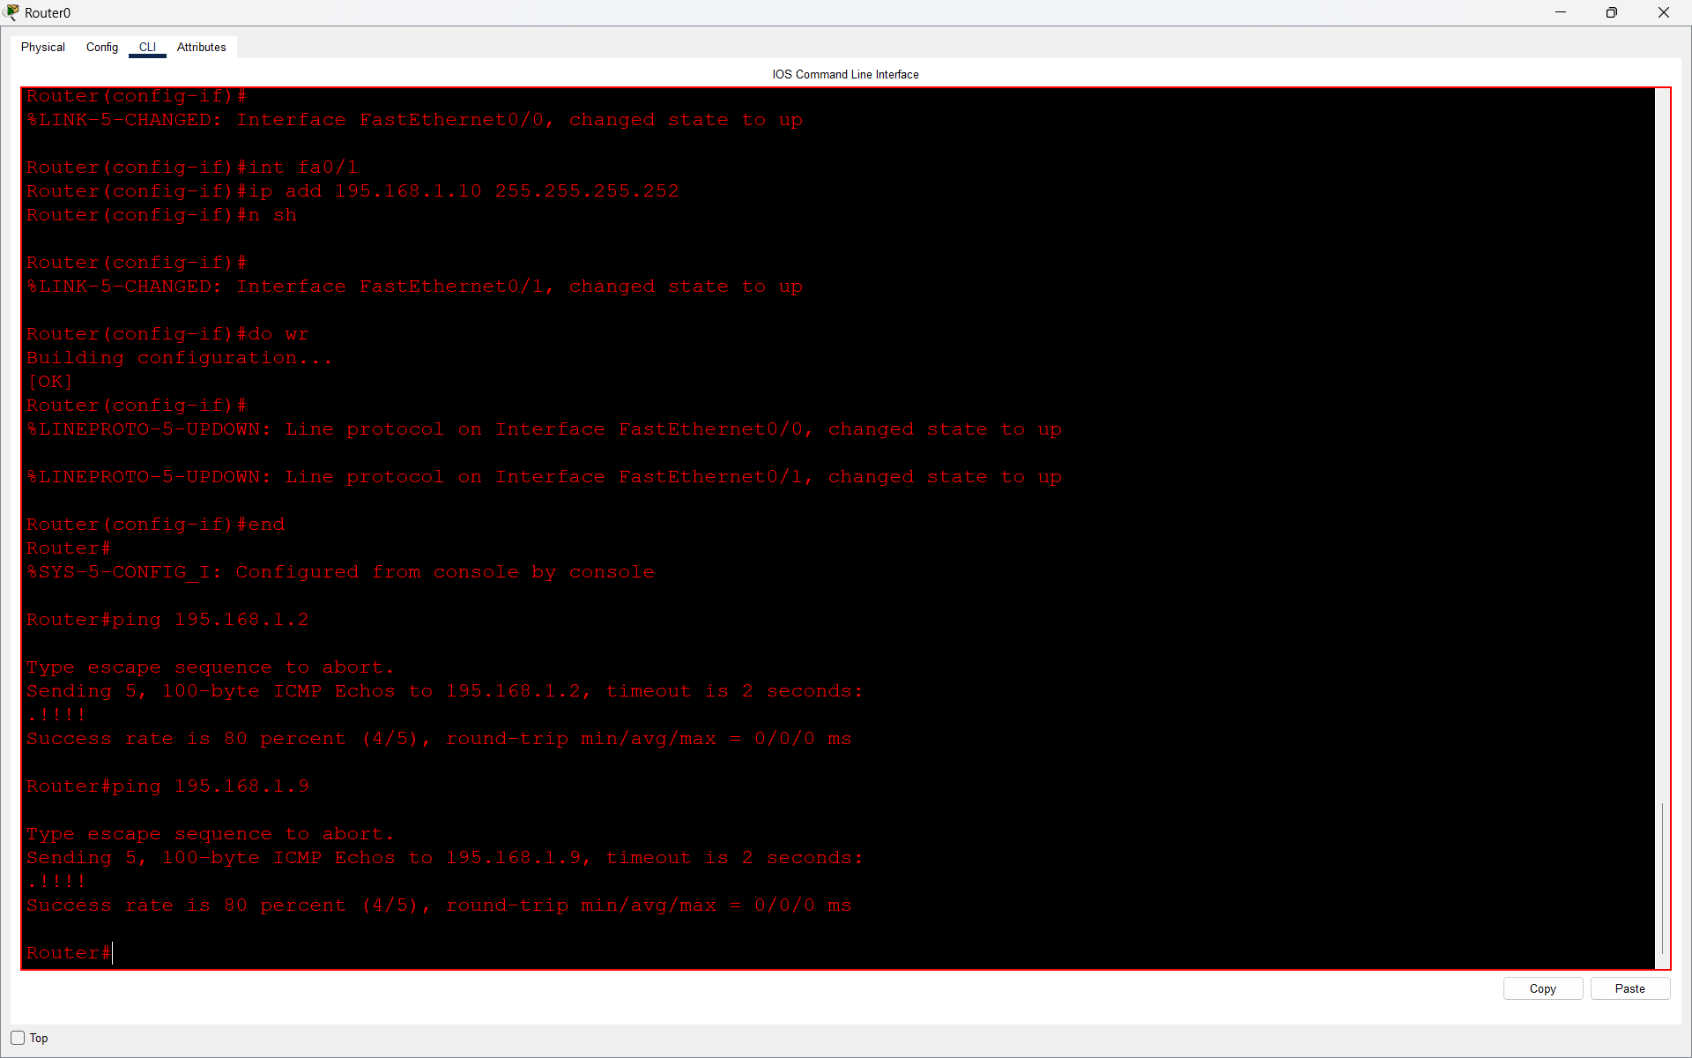

Q3. Configure OSPF on each router using the router ospf 1 command and the network command to advertise all directly connected networks?

Answer
- I configured OSPF on all three routers using the router ospf 1 command and advertised the directly connected networks using the network command in Area 0.
- I verified the configuration using show ip route ospf. The routing table displayed OSPF-learned routes marked with O, confirming that OSPF was working successfully.

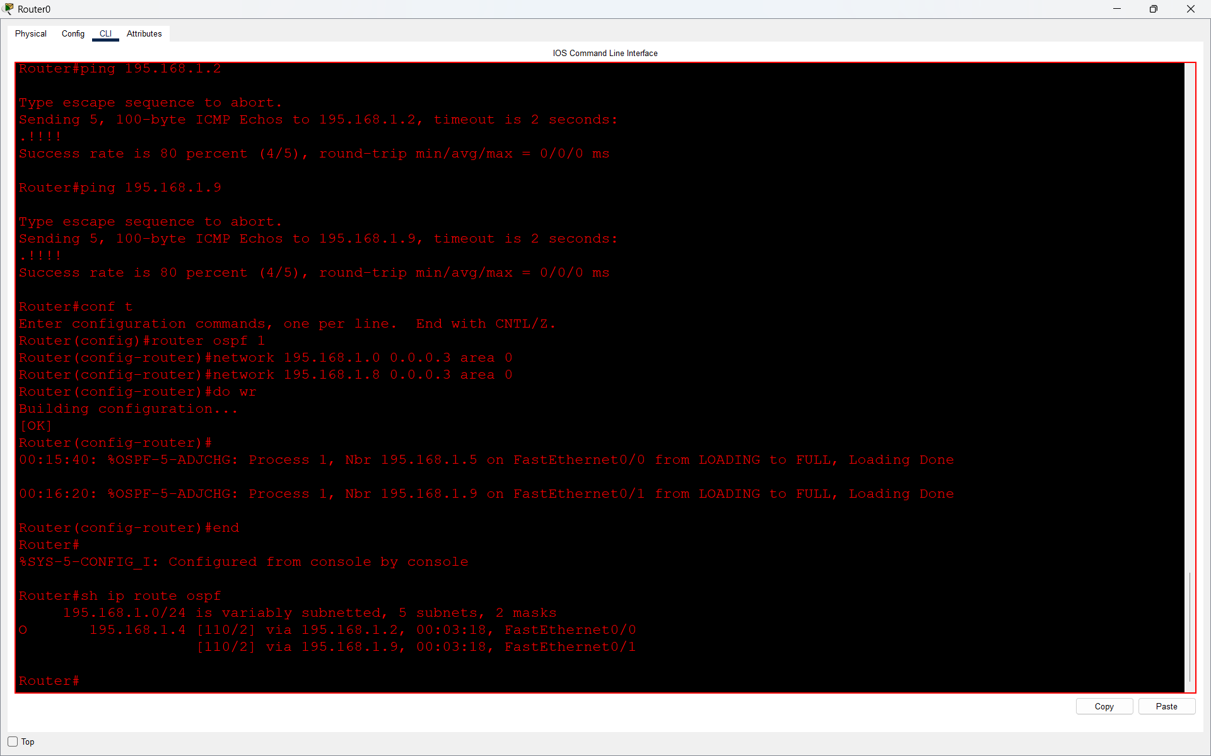

Q4. Observe and document the OSPF adjacency formation process by checking the output of the show ip ospf neighbor command on each router.<br><br><em><strong>Hint:</strong> Look for the FULL/DR or FULL/BDR state to confirm adjacency.</em>?

Answer
- I used the show ip ospf neighbor command on all three routers to observe OSPF neighbor relationships.
- I observed that OSPF neighbors formed adjacencies through different states and finally reached FULL/DR or FULL/BDR.
- Each router successfully established adjacency with the other two routers.
- Result: All three routers formed successful OSPF neighbor relationships and reached the FULL state.
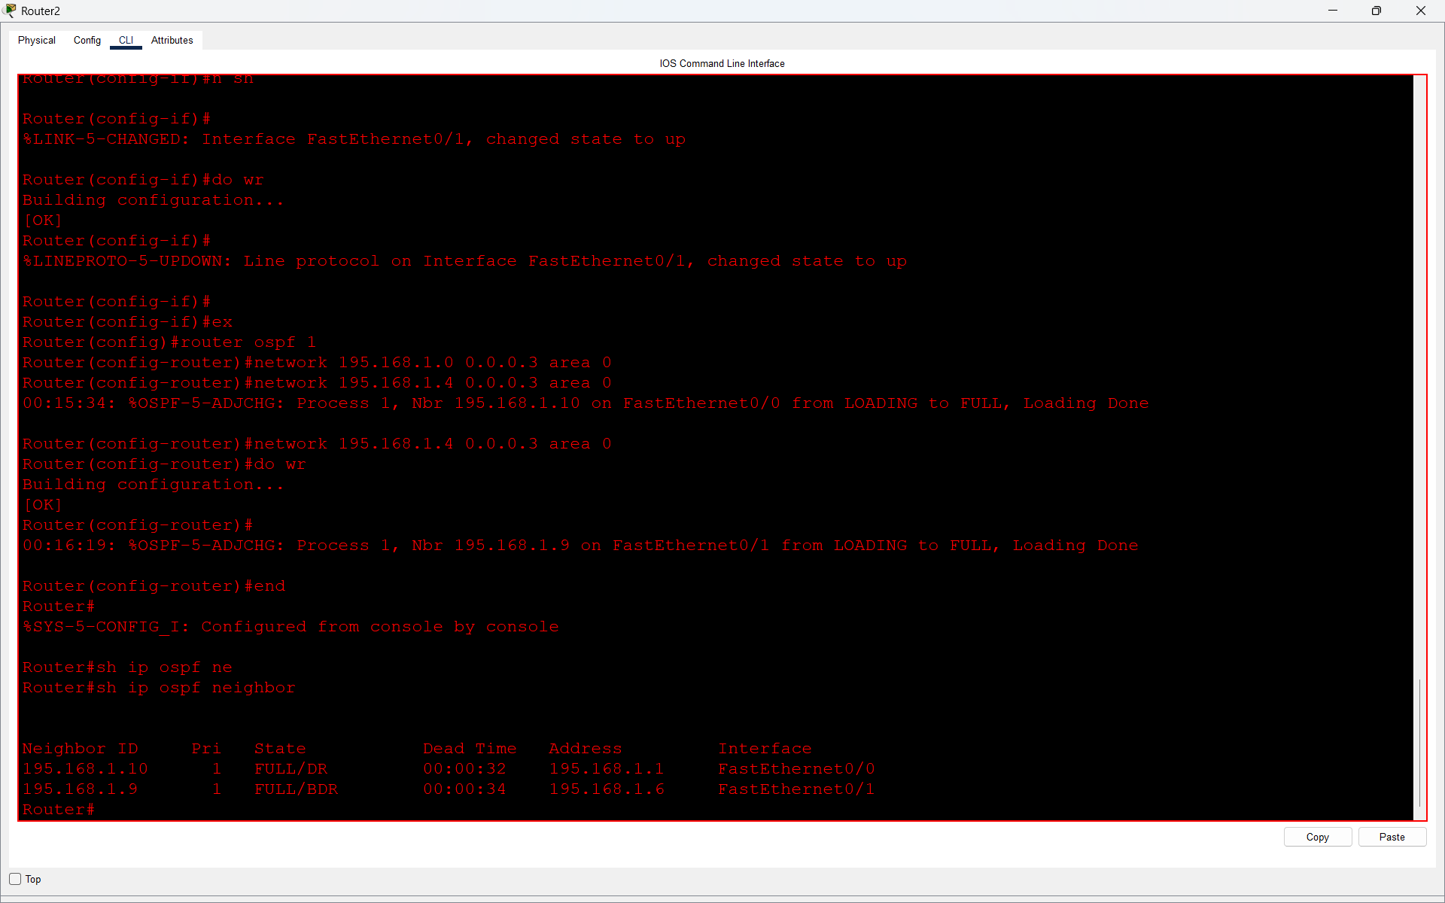
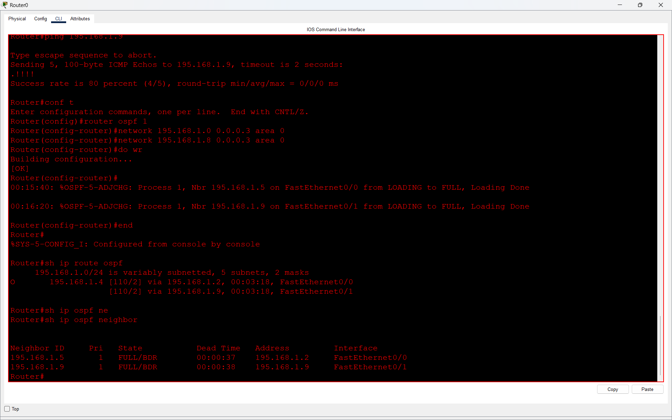

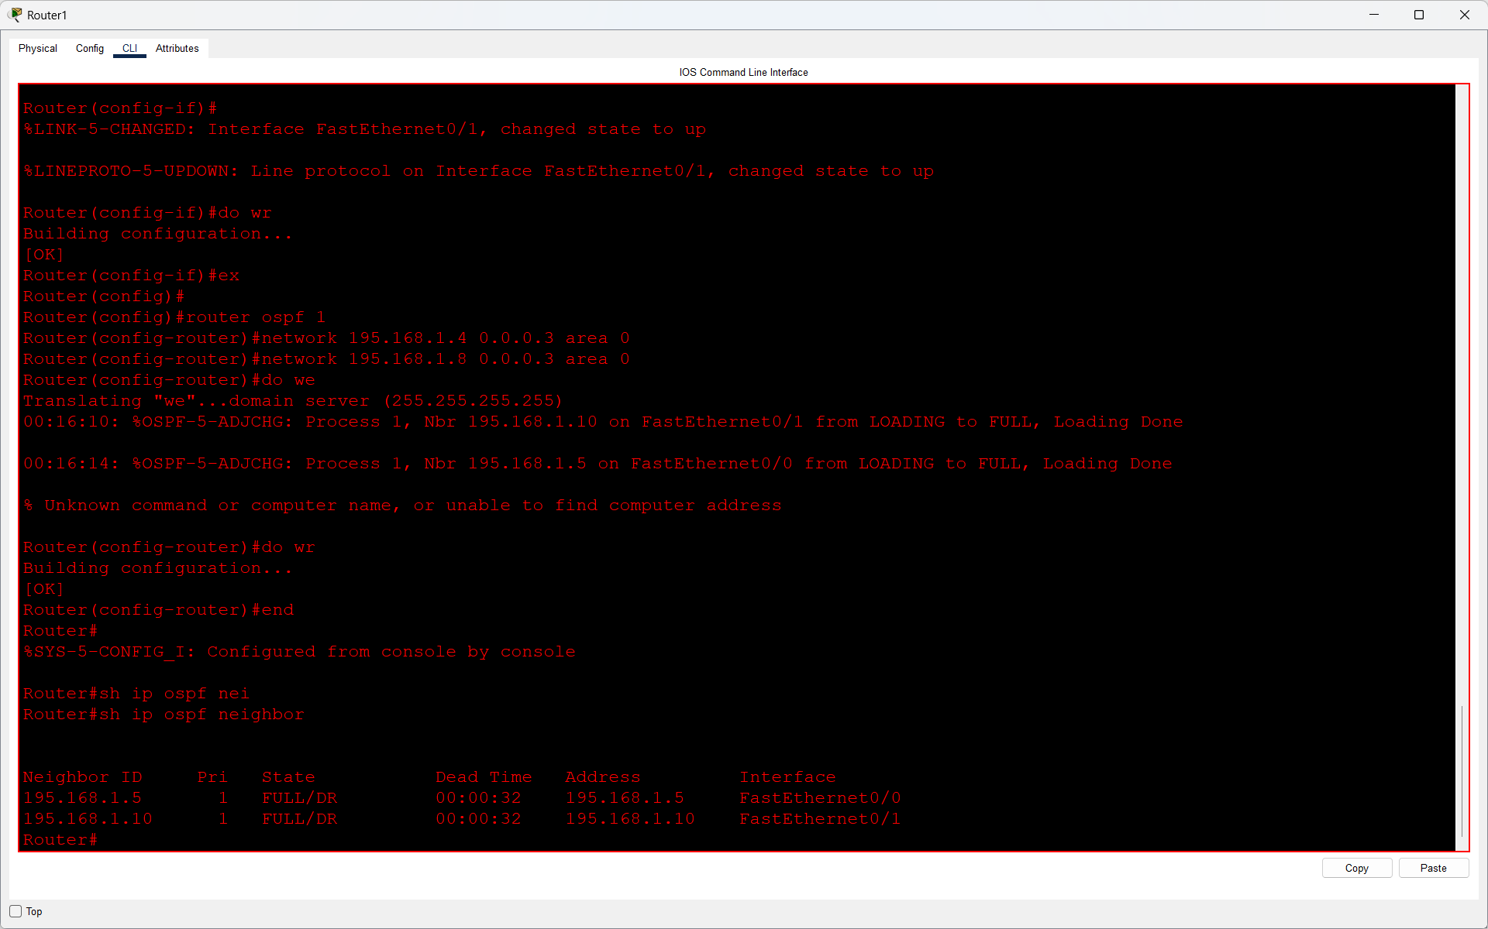

Q5 Change the OSPF cost on one interface using the ip ospf cost command and verify how it affects the OSPF routing table.<br><br><em><strong>Hint:</strong> Use show ip route ospf to see route changes after modifying the cost.</em>?

Answer
- I changed the OSPF cost on Router0's FastEthernet0/1 interface using the command:
- ip ospf cost 10
- Before changing the cost, Router0 had two equal-cost paths to network 195.168.1.4/30.
- After changing the cost, I checked the routing table using show ip route ospf.
- OSPF selected the lower-cost path through 195.168.1.2 instead of using both paths.
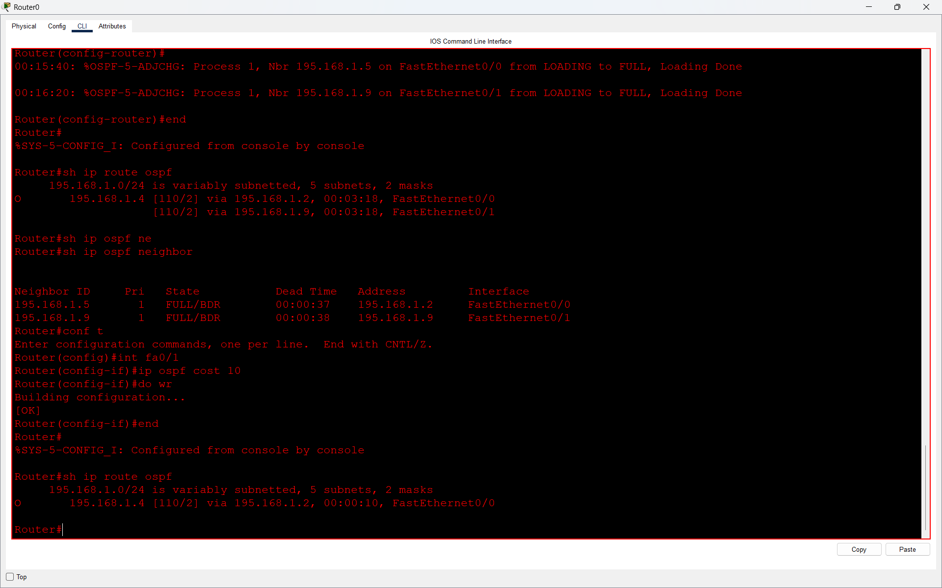
- Result: Changing the OSPF cost affected path selection, and OSPF preferred the route with the lower cost.

